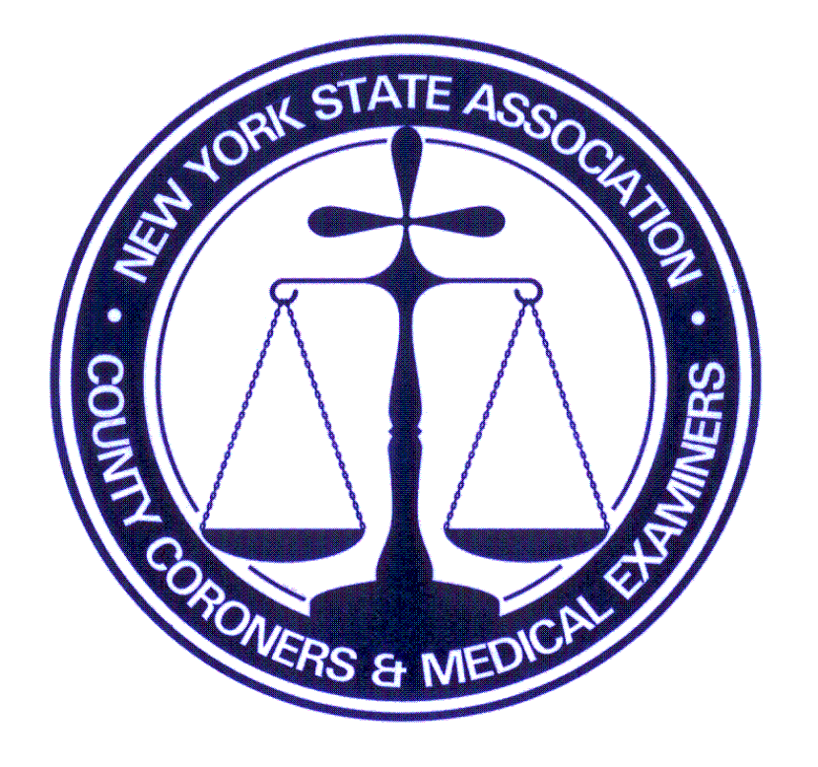**NYSACCME**

Fall Conference

Saturday, September 13, 2025

Sunday, September 14, 2025

Lake Ontario Conference

26 E 1st Street

Oswego NY 13126

6179 Middle Rd Munnsville , New York 13409

Telephone 315-750-6997

[tgreenwood@nysaccme.org](mailto:tgreenwood@nysaccme.org) website [www.nysaccme.org](http://www.nysaccme.org)

**REGISTRATION FORM**

**Name_______________________________________________________________________________**

Address __________________________________ Telephone __________________________________

City________________________ State ________________ Zip Code ___________________________

E-Mail Address _______________________________________________________________________

Representing (County/Organization) ______________________(Funeral Home)____________________

**RESERVATIONS AND PAYMENTS ARE MADE THROUGH THE NYSACCME OFFICE**

**MUST BE POST Marked NO LATER THAN September 1th 2025**

**FIRST COME FIRST SERVE ON ROOMS. 50.00 late charge if received after date.**

**Package 1: NYSACCME MEMBER: $650 NON-MEMBER: $750**  **$ ________**

* Friday and Saturday night lodging
* Saturday breakfast, breaks, lunch, dinner
* Sunday breakfast, break ,check out Sunday at 11am

**If applicable: Spouse/guest weekend meal package: $175 $ ________**

**Spouse/guest Saturday dinner only: $50 $ ________**

**TOTAL AMOUNT DUE (CHECK or MONEY ORDER PAYABLE TO: NYSACCME)** **$ ________**

**Package 2: NYSACCME MEMBER: $500 NON-MEMBER: $600** **$ ________**

* Saturday night lodging
* Saturday breakfast, breaks, lunch, dinner Check out Saturday 11am
* Sunday breakfast, break

**If applicable: Spouse/guest weekend meal package: $175 $ ________**

**Spouse/guest Saturday dinner only: $50 $ ________**

**TOTAL AMOUNT DUE (CHECK or MONEY ORDER PAYABLE TO: NYSACCME)** **$ ________**

**Package 3: NYSACCME MEMBER: $350 NON-MEMBER: $450** **$ ________**

* **No lodging (commuter)**
* Saturday breakfast, breaks, lunch, dinner included
* Sunday breakfast, break

**If applicable: Spouse/guest weekend meal package: $175 $ ________**

**Spouse/guest Saturday dinner only: $50 $ ________**

**TOTAL AMOUNT DUE (CHECK or MONEY ORDER PAYABLE TO: NYSACCME)** **$ ________**

**Make a copy of this form and your check/MO; it is your receipt to submit to your county for reimbursement, if applicable. PLEASE GIVE COUNTY ASAP**

**ronm**

**$25 Service Charge will apply for checks returned for Non-Sufficient Funds (NSF) and/or a refund fee**

**(*NON-REFUNDABLE CANCELLATION FEE: Member-$100 / Non-Member-$200*)**

**CANCELLATIONS MUST BE DONE THROUGH THE NYSACCME OFFICE.**

**THERE WILL BE CANCELLATION CHARGES FOR *ROOM RESERVATIONS* CANCELLED WITH LESS THAN**

**48 HOUR NOTICE AND *MEAL PACKAGE* WITH LESS THAN A WEEK PRIOR TO CONFERENCE.**

***I have read and agreed to the terms specified above:__________________________________________________***

**PRINT NAME**

**FOR OFFICE USE ONLY:** Total paid $______________ Check Number ____________ 6/2025 tg

**NYSACCME**

Conference

Info will be placed here:

6179 Middle Rd Munnsville , New York 13409

Telephone 315-750-6997

[tgreenwood@nysaccme.org](mailto:tgreenwood@nysaccme.org) website [www.nysaccme.org](http://www.nysaccme.org)

**REGISTRATION FORM**

Dear Members and NYS County Clerks;

Please note our Conference registration prices will be changing ***after*** the Fall Conference September 2025

Effective as of March 2026 .

NYSACCME will reserve a block of rooms at all venues, it is up to **our members** to book lodging with event center. These will fill up fast. Please note the conference price does **NOT** include lodging. Please reach out to our Administrator Tami Greenwood with any questions.

Future Registration will appear as this: **Registration Details**

|  |  |  |  |
| --- | --- | --- | --- |
| **Registration Type:** | Regular | Student 500.00 | Late/On-site |
| **Registration Fee:** | Member $500.00 | Non- Member $600 | Late fee 25.00 |
|  |
|  |
| **Meals included Breakfast,lunch, break and dinner on Saturday.** | | | |
| **Lodging is member responsibility.** | | | |

March 20, 2026/ 8:00 am - 5:00 pm EDT

[**Coroner 101 March 20th Tioga Downs**](https://www.nysaccme.org/event/coroner-101-march-20th-tioga-downs/)

**2384 W RIVER RD NICHOLS NY**

March 21, 2026/ 7:00 am - March 22, 2026/ 5:00 pm EDT

[**Spring Conference March 21-22nd  Tioga Downs**](https://www.nysaccme.org/event/2026-spring-conference/)

**2384 W RIVER RD NICHOLS NY**



**Tami Greenwood NYSACCME Administrator**

[tgreenwood@nysaccme.org](mailto:tgreenwood@nysaccme.org)

O-315-750-6997

C-315-886-1660