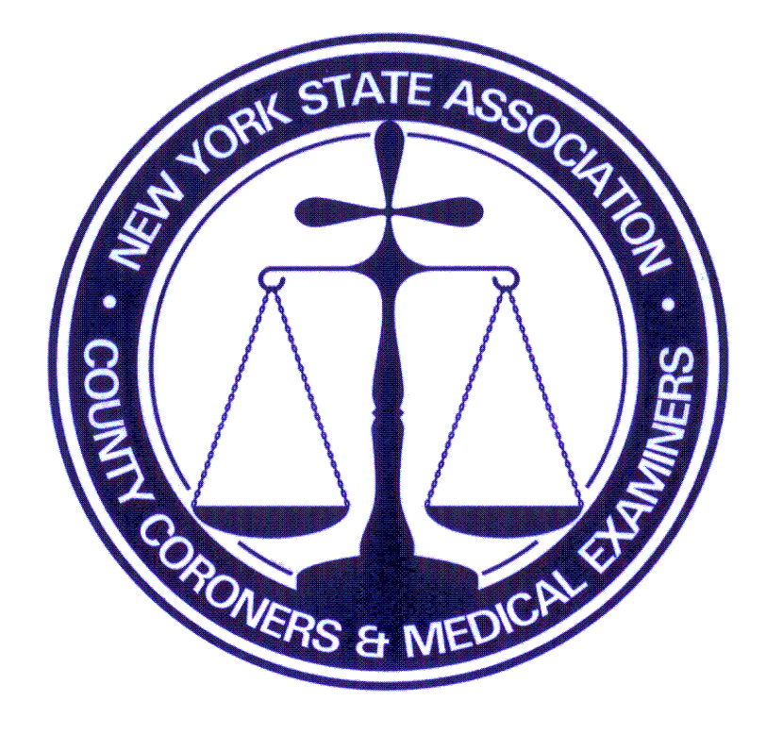
NYSACCME
Fall Conference
Friday, September 29
Sunday, October 1, 2023
Lake Ontario Event Center
Oswego, NY 13126

6179 Middle Rd Munnsville , New York 13409
Telephone 315-750-6997
tgreenwood@nysaccme.org www.nysaccme.org

REGISTRATION FORM
Address __________________________________ Telephone __________________________________
City________________________ State ________________ Zip Code ___________________________
E-Mail Address _______________________________________________________________________
Representing (County/Organization) ______________________(Funeral Home)____________________

RESERVATIONS & PAYMENTS ARE MADE WITH NYSACCME OFFICE NOT HOTEL
POST MARKED NO LATER THAN September 8th 2023
***No applications will be accepted via email *** Please submit to county ASAP

Package 1: NYSACCME MEMBER: $600 NON-MEMBER: $700 $ ________
- Friday and Saturday night lodging
- Saturday breakfast, breaks, lunch, dinner
- Sunday breakfast, break
If applicable: Spouse/guest weekend meal package: $175 $ ________
Spouse/guest Saturday dinner only: $50 $ ________
TOTAL AMOUNT DUE (CHECK or MONEY ORDER PAYABLE TO: NYSACCME) $ ________

Package 2: NYSACCME MEMBER: $450 NON-MEMBER: $550 $ ________
- Saturday night lodging
- Saturday breakfast, breaks, lunch, dinner
- Sunday breakfast, break
If applicable: Spouse/guest weekend meal package: $175 $ ________
Spouse/guest Saturday dinner only: $50 $ ________
TOTAL AMOUNT DUE (CHECK or MONEY ORDER PAYABLE TO: NYSACCME) $ ________

Package 3: NYSACCME MEMBER: $300 NON-MEMBER: $400. $ ________
- No lodging (commuter)
- Saturday breakfast, breaks, lunch, dinner
- Sunday breakfast, break
If applicable: Spouse/guest weekend meal package: $175 $ ________
Spouse/guest Saturday dinner only: $50 $ ________
TOTAL AMOUNT DUE (CHECK or MONEY ORDER PAYABLE TO: NYSACCME) $ ________

Please send full payment (check or money order) with Registration Form.
REGISTRATION FORM MUST BE SUBMITTED WITH PAYMENT
Make a copy of this form and your check/MO; it is your receipt to submit to your county for reimbursement, if applicable.

$25 Service Charge will apply for checks returned for Non-Sufficient Funds (NSF)
(NON-REFUNDABLE CANCELLATION FEE: Member-$100 / Non-Member-$200)
CANCELLATIONS MUST BE DONE THROUGH THE NYSACCME OFFICE.
THERE WILL BE CANCELLATION CHARGES FOR ROOM RESERVATIONS CANCELLED WITH LESS THAN
48 HOUR NOTICE AND MEAL PACKAGE WITH LESS THAN A WEEK PRIOR TO CONFERENCE.

I have read and agreed to the terms specified above:__________________________________________________
Registrant’s Signature

FOR OFFICE USE ONLY: Total paid $______________ Check Number ____________ 3/2023 tg

